RideNova Vehicle & Fleet Management System

Salesforce Admin Project Documentation

Prepared By

Khushi Sheoran

Bachelor of Technology (B.Tech)
Computer Science and Engineering (CSE)

Meerut Institute of Engineering and Technology (MIET)
Meerut

Table of Contents
1. Project Overview

2. Project Architecture

3. Custom Objects & Fields

4. Validation Rules

5. Record-Triggered Flows

6. Reports and Dashboards

7. Lightning App & User Interface

8. Challenges Faced

9. Learning Outcomes

10. Future Scope

11. Conclusion

1. Project Overview
1.1 Project Title
RideNova Vehicle & Fleet Management System

1.2 Introduction
RideNova Vehicle & Fleet Management System is a Salesforce Admin project developed to manage vehicle rental operations in a simple and organized way.
The system helps manage vehicles, customer bookings, payments, maintenance records, driver assignments, vehicle inspections, customer feedback, and support tickets from one platform.
This project is created using Salesforce Admin tools such as Custom Objects, Fields, Validation Rules, Flows, Reports, Dashboards, Page Layouts, Permission Sets, and Lightning App Builder.

1.3 Problem Statement
Many vehicle rental businesses manage their records manually or in different files, which makes it difficult to track bookings, vehicle availability, payments, maintenance schedules, and customer issues.
This project provides a centralized Salesforce solution to manage all these operations efficiently.

1.4 Project Objectives
- Manage vehicle information.
- Record customer bookings.
- Track payments.
- Maintain vehicle service history.
- Assign drivers to bookings.
- Record vehicle inspections.
- Manage customer feedback.
- Handle customer support tickets.
- Generate reports and dashboards for business insights.

1.5 Scope of the Project
This project is designed for learning Salesforce Administration and demonstrates how Salesforce can be used to automate a vehicle rental business.
The project includes:
- Vehicle Management
- Booking Management
- Payment Management
- Vehicle Maintenance
- Driver Assignment
- Vehicle Inspection
- Customer Feedback
- Support Ticket Management
- Reports & Dashboards

2. Project Architecture
2.1 Project Modules
The RideNova Vehicle & Fleet Management System is divided into different modules. Each module is responsible for managing a specific business process.
The main modules of the project are:
• Vehicle Management
• Booking Management
• Payment Management
• Vehicle Maintenance
• Driver Assignment
• Vehicle Inspection
• Customer Feedback
• Support Ticket Management
• Reports and Dashboards
2.2 Custom Objects
Object Name | Purpose
Vehicle | Stores vehicle details and availability.
Booking | Stores customer booking information.
Payments | Stores payment details for each booking.
Vehicle Maintenance | Tracks vehicle service and maintenance records.
Driver Assignment | Stores driver assignment details.
Vehicle Inspection | Stores vehicle inspection records before and after rental.
Customer Feedback | Stores customer ratings and feedback.
Support Ticket | Stores customer complaints and support requests.

2.3 Object Relationships
The RideNova Vehicle & Fleet Management System uses Lookup Relationships to connect different objects. These relationships help maintain data consistency and make it easier to manage the complete vehicle rental process.Each booking is connected with a vehicle, payment, driver assignment, inspection, customer feedback, and support ticket. Vehicle maintenance records are directly connected to the vehicle object.
Vehicle
│
├────────► Booking
│ │
│ ├────────► Payment
│ ├────────► Driver Assignment
│ ├────────► Vehicle Inspection
│ ├────────► Customer Feedback
│ └────────► Support Ticket
│
└────────► Vehicle Maintenance
Relationship Summary
Parent Object |  |  |  |  |  |  |  |  |  |  |  | Child Object |  |  |  |  |  |  |  |  |  |  |  |  |  | Relationship Type
Vehicle |  |  |  |  |  |  |  |  |  |  |  | Booking |  |  |  |  |  |  |  |  |  |  |  |  |  | Lookup
Vehicle |  |  |  |  |  |  |  |  |  |  |  | Vehicle Maintenance |  |  |  |  |  |  |  |  |  |  |  |  |  | Lookup
Booking |  |  |  |  |  |  |  |  |  |  |  | Payment |  |  |  |  |  |  |  |  |  |  |  |  |  | Lookup
Booking |  |  |  |  |  |  |  |  |  |  |  | Driver Assignment |  |  |  |  |  |  |  |  |  |  |  |  |  | Lookup
Booking |  |  |  |  |  |  |  |  |  |  |  | Vehicle Inspection |  |  |  |  |  |  |  |  |  |  |  |  |  | Lookup
Booking |  |  |  |  |  |  |  |  |  |  |  | Customer Feedback |  |  |  |  |  |  |  |  |  |  |  |  |  | Lookup
Booking |  |  |  |  |  |  |  |  |  |  |  | Support Ticket |  |  |  |  |  |  |  |  |  |  |  |  |  | Lookup

3. Custom Fields
3.1 Vehicle Object
The Vehicle object stores all information related to rental vehicles. It helps the company manage vehicle details, rental pricing, availability, registration details, and technical specifications.
Field Name | Purpose
Vehicle Name | Stores the name of the vehicle.
Brand | Stores the vehicle brand.
Model | Stores the model name.
Vehicle Type | Stores the type of vehicle.
Daily Rent | Stores the rental price per day.
Availability Status | Shows whether the vehicle is available or booked.
Registration Number | Stores the registration number.

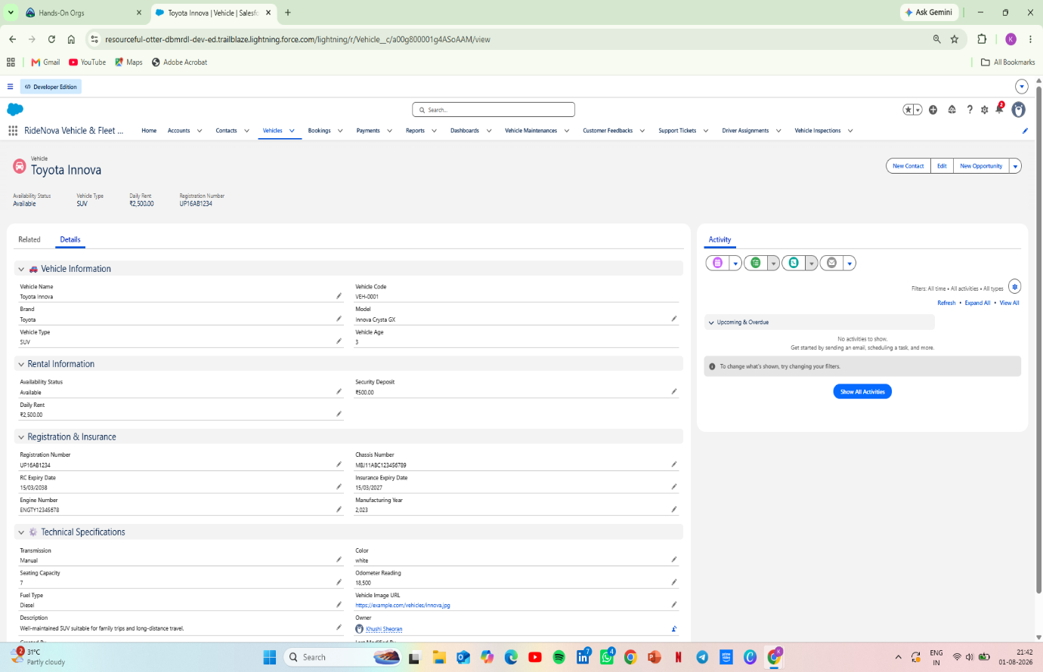
Figure 3.1 – Vehicle Record Page
3.2 Booking Object
The Booking object stores all customer booking information. It helps manage vehicle reservations, booking dates, rental duration, booking status, and customer details.
Field Name | Purpose
Booking Number | Stores the unique booking ID.
Customer | Stores the customer details.
Vehicle | Stores the selected vehicle.
Pickup Date | Stores the pickup date.
Return Date | Stores the return date.
Total Rental Days | Calculates the total rental period.
Booking Status | Shows the booking status.
Total Amount | Stores the total booking amount.
Figure 3.2 – Booking Record Page
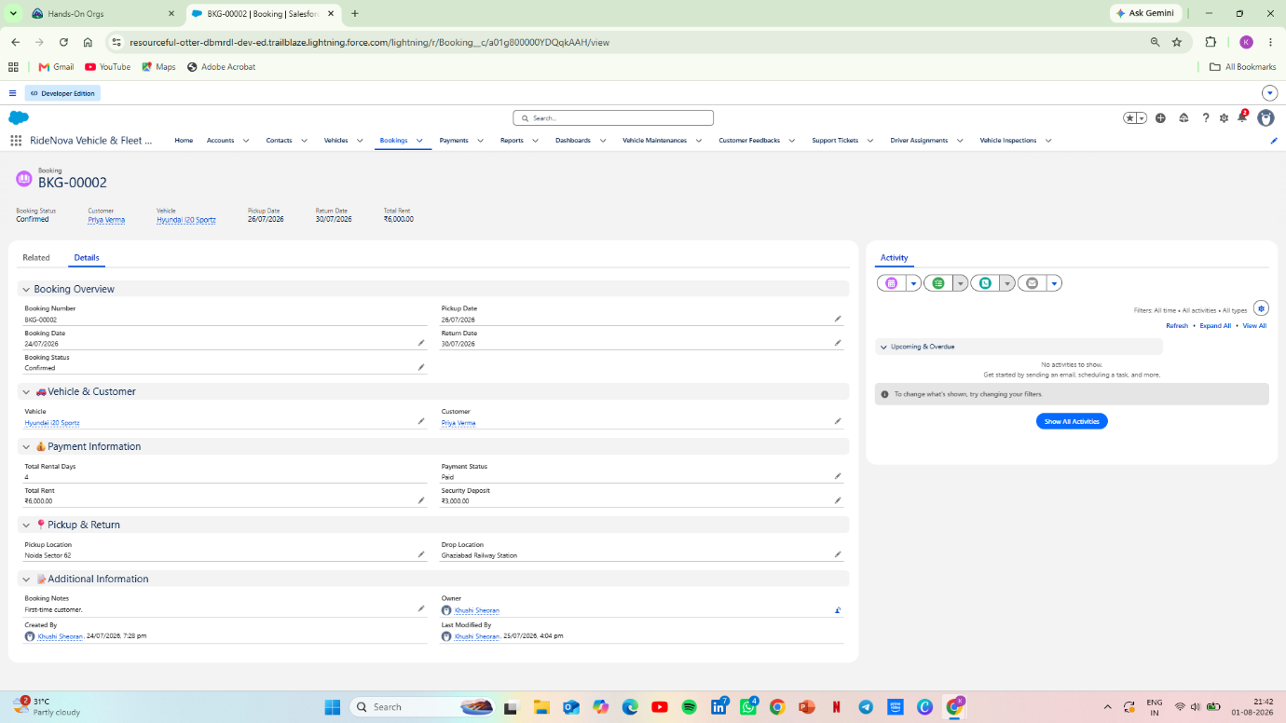
3.3 Payment Object
The Payment object stores all payment information related to customer bookings. It helps track payment amount, payment method, payment status, and transaction details. This module makes payment management simple and organized.
Field Name | Purpose
Payment ID | Stores the unique payment ID.
Booking | Links the payment to a booking.
Payment Amount | Stores the payment amount.
Payment Date | Stores the payment date.
Payment Method | Stores the payment method.
Payment Status | Shows whether the payment is completed or pending.
Transaction ID | Stores the transaction reference number.
Figure 3.3 – Payment Record Page
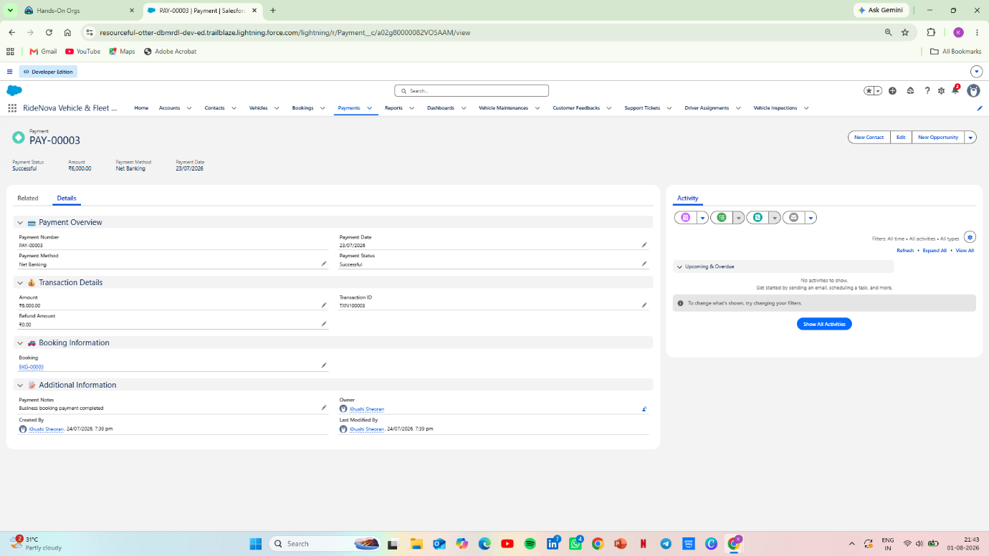
3.4 Vehicle Maintenance Object
The Vehicle Maintenance object stores maintenance and service records of vehicles. It helps track service schedules, maintenance costs, service status, and maintenance dates. This module ensures that vehicles remain in good condition before they are rented to customers.
Field Name | Purpose
Maintenance ID | Stores the unique maintenance record ID.
Vehicle | Links the maintenance record to a vehicle.
Maintenance Type | Stores the type of maintenance.
Maintenance Date | Stores the maintenance date.
Maintenance Cost | Stores the maintenance cost.
Service Status | Shows the current maintenance status.
Remarks | Stores additional maintenance notes.
Figure 3.4 – Vehicle Maintenance Record Page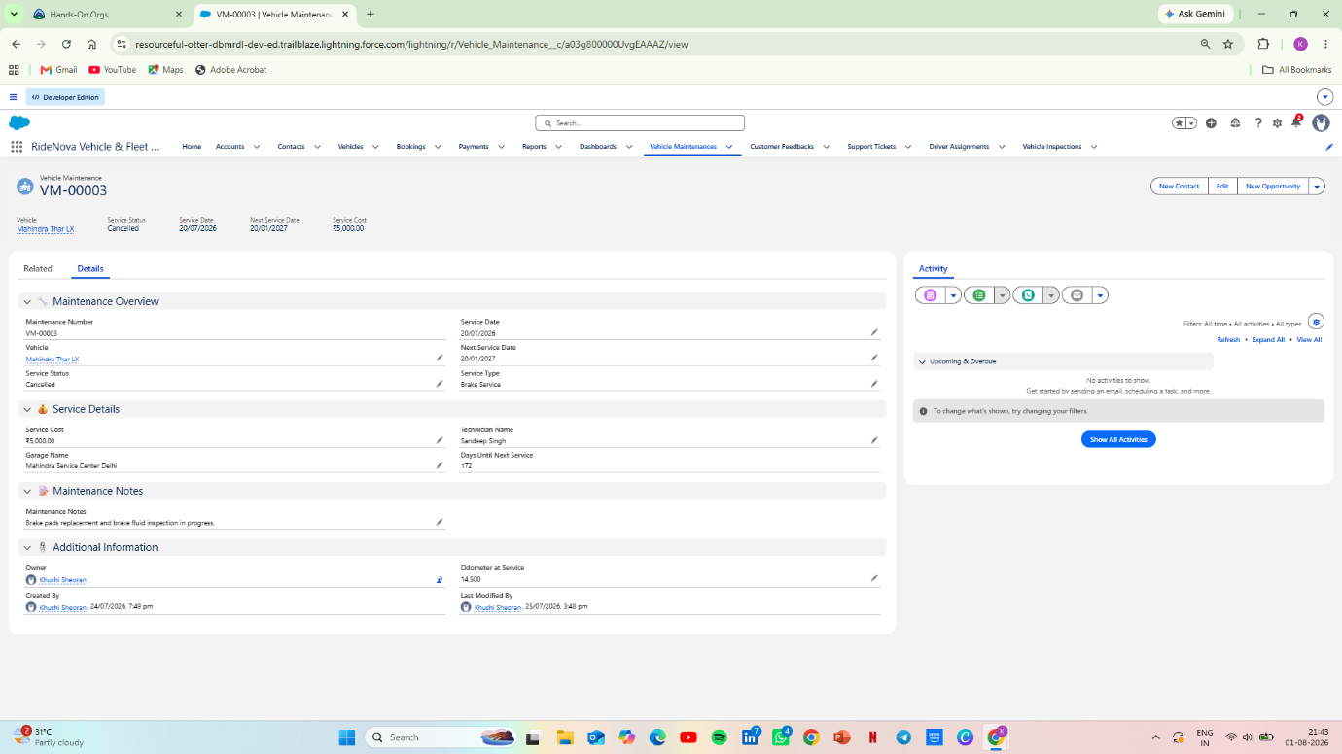3.5 Driver Assignment Object
The Driver Assignment object is used to assign drivers to customer bookings. It stores driver information, assigned vehicle details, assignment date, and assignment status. This module helps manage drivers efficiently and avoids confusion during vehicle delivery.
Field Name | Purpose
Assignment ID | Stores the unique assignment ID.
Booking | Links the assignment to a booking.
Driver | Stores the assigned driver details.
Vehicle | Stores the assigned vehicle.
Assignment Date | Stores the assignment date.
Assignment Status | Shows whether the driver is assigned or completed.
Remarks | Stores additional notes related to the assignment.
Figure 3.5 – Driver Assignment Record Page
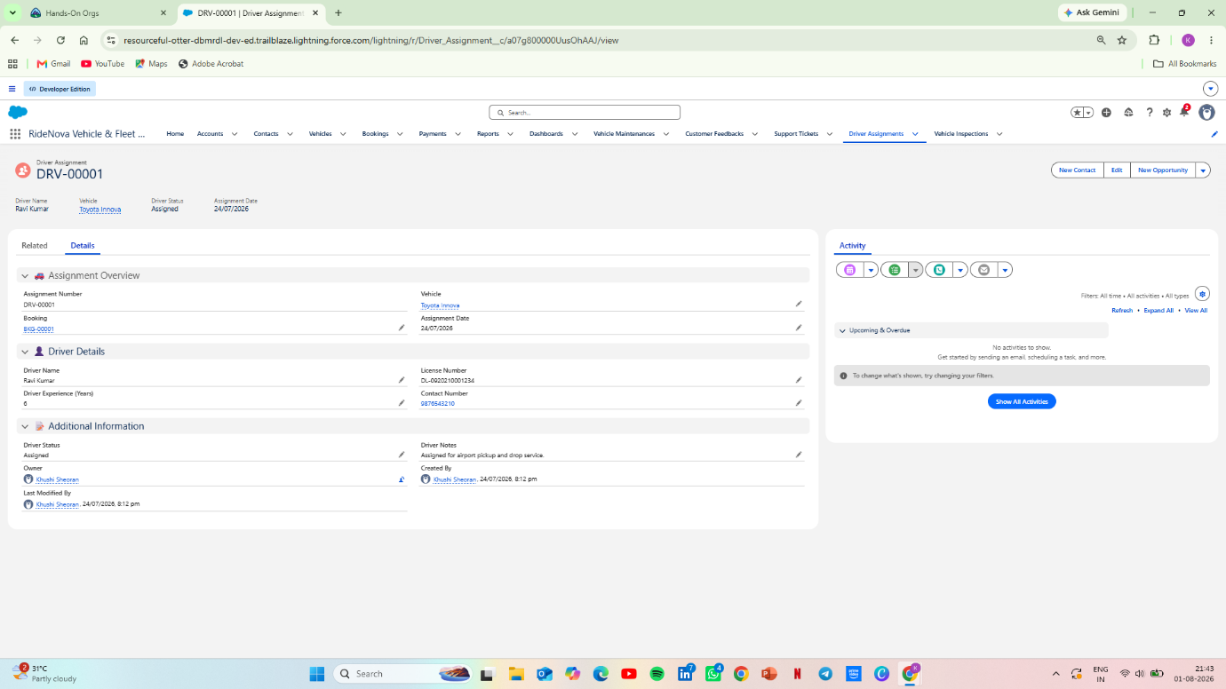
3.6 Vehicle Inspection Object
The Vehicle Inspection object is used to record the condition of a vehicle before and after the rental period. It helps identify any damage, additional charges, and inspection remarks. This module ensures transparency between the company and the customer.
Field Name | Purpose
Inspection ID | Stores the unique inspection ID.
Booking | Links the inspection to a booking.
Vehicle | Stores the inspected vehicle details.
Inspection Date | Stores the inspection date.
Vehicle Condition | Stores the condition of the vehicle.
Damage Charges | Stores additional damage charges, if any.
Inspection Remarks | Stores inspector's remarks.
Figure 3.6 – Vehicle Inspection Record Page
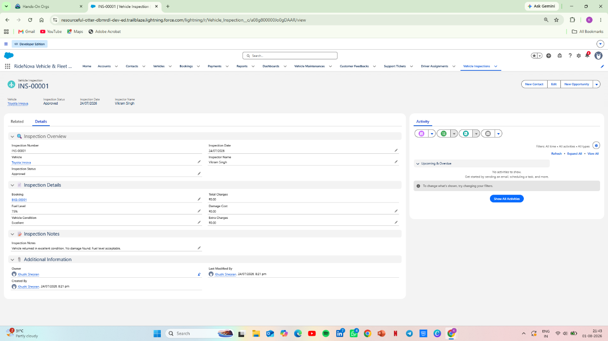
3.7 Customer Feedback Object
The Customer Feedback object stores customer reviews and ratings after the rental service. It helps the company understand customer satisfaction, improve service quality, and maintain a better customer experience.
Field Name | Purpose
Feedback ID | Stores the unique feedback ID.
Booking | Links the feedback to a booking.
Customer | Stores customer details.
Rating | Stores the customer rating.
Feedback Date | Stores the feedback submission date.
Comments | Stores customer comments.
Feedback Status | Shows whether the feedback has been reviewed
Figure 3.7 – Customer Feedback Record Page

3.8 Support Ticket Object
The Support Ticket object is used to manage customer complaints and support requests. It helps track issues, monitor ticket status, assign priorities, and record resolutions. This module improves customer service and ensures that every issue is resolved on time.
Field Name | Purpose
Ticket ID | Stores the unique support ticket ID.
Customer | Stores customer details.
Booking | Links the ticket to a booking.
Issue Type | Stores the type of issue reported.
Priority | Stores the priority level of the ticket.
Status | Shows the current ticket status.
Resolution Notes | Stores the solution provided for the issue.
Figure 3.8 – Support Ticket Record Page
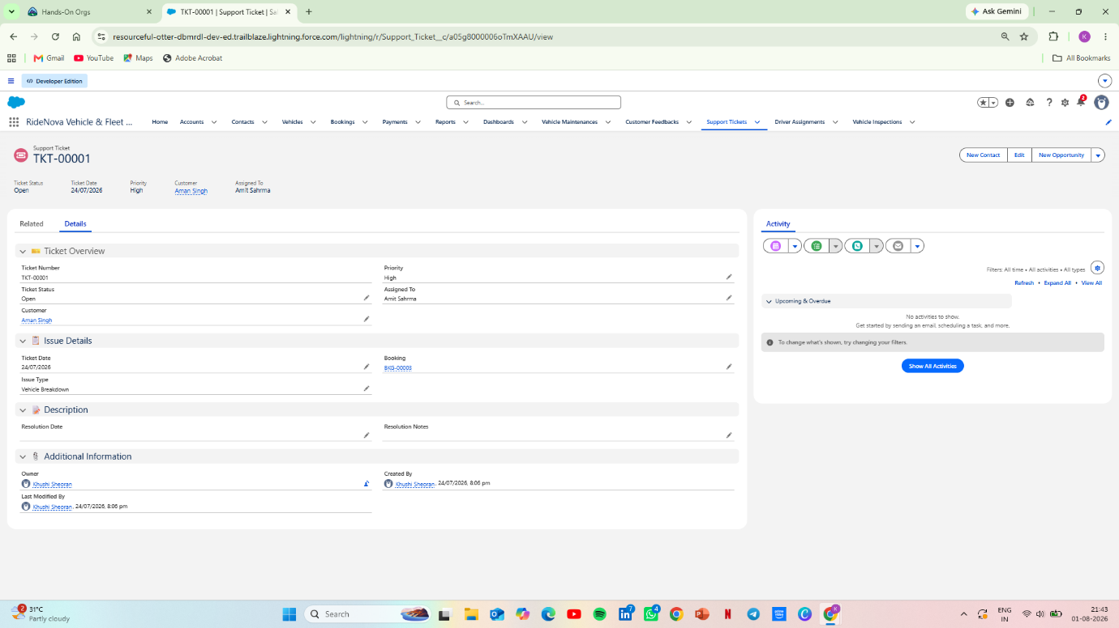
4. Validation Rules
4.1 Introduction
Validation Rules are used to maintain data accuracy and prevent users from entering incorrect information. In the RideNova project, validation rules ensure that only valid and meaningful data is saved in the system. This improves data quality and reduces manual errors.
4.2 Validation Rules Implemented
Object | Validation Rule
Vehicle | Daily Rent cannot be less than or equal to 0.
Booking | Return Date must be greater than Pickup Date.
Payment | Payment Amount must be greater than 0.
Vehicle Maintenance | Maintenance Cost cannot be negative.
Vehicle Inspection | Damage Charges cannot be negative.
Customer Feedback | Rating must be between 1 and 5.
4.3 Benefits of Validation Rules
• Prevents invalid data entry.
• Improves data accuracy.
• Reduces manual mistakes.
• Ensures business rules are followed.
• Maintains consistency across records.
The validation rules were implemented to improve data accuracy and ensure that only valid information is stored in the system.
5. Record-Triggered Flows
5.1 Introduction
Record-Triggered Flows are used to automate business processes without writing code. In the RideNova project, flows automatically update records and reduce manual work. This improves efficiency and ensures that business processes run smoothly.
5.2 Flows Implemented
Flow Name | Purpose
Vehicle Booking Flow | Updates vehicle status when a booking is created.
Payment Flow | Updates payment information after payment is completed.
Vehicle Maintenance Flow | Updates maintenance status after service completion.
Vehicle Inspection Flow | Records inspection details after vehicle return.
Driver Assignment Flow | Assigns drivers to confirmed bookings.
5.3 Benefits of Flows
• Reduces manual work.
• Automates business processes.
• Improves data accuracy.
• Saves time.
• Provides a better user experience.
6. Reports and Dashboards
6.1 Introduction
Reports and Dashboards are used to analyze business data and support better decision-making. In the RideNova project, reports help organize records, while dashboards provide a visual summary of important business information.
6.2 Reports Created
Report Name | Purpose
Vehicle Report | Displays all vehicle records and their details.
Booking Report | Displays customer booking information.
Payment Report | Tracks payment records and payment status.
Maintenance Report | Shows vehicle maintenance history.
Driver Assignment Report | Displays driver assignment details.

6.3 Dashboard Components
Dashboard Component | Purpose
Vehicle Availability | Shows available and booked vehicles.
Booking Status | Displays booking status.
Payment Summary | Shows payment information.
Maintenance Status | Tracks vehicle maintenance records.
Driver Assignment | Displays assigned drivers.
Customer Feedback | Shows customer ratings and feedback.

Figure 6.1 – RideNova Dashboard
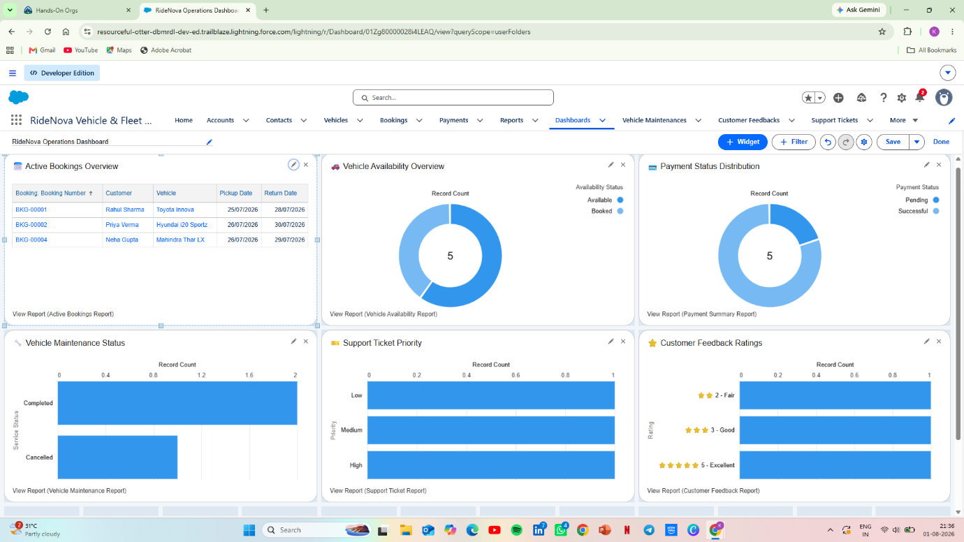
7. Lightning App & User Interface
7.1 Introduction
The RideNova application uses Salesforce Lightning App Builder to create a simple, user-friendly, and professional interface. Different record pages are customized to improve navigation and provide users with all important information in one place.
7.2 Home Page
The Home Dashboard provides a quick overview of the entire RideNova system. Users can view important business information such as vehicle availability, booking status, payment summary, maintenance status, driver assignments, and customer feedback from one page.
Figure 7.1 – RideNova Home Dashboard
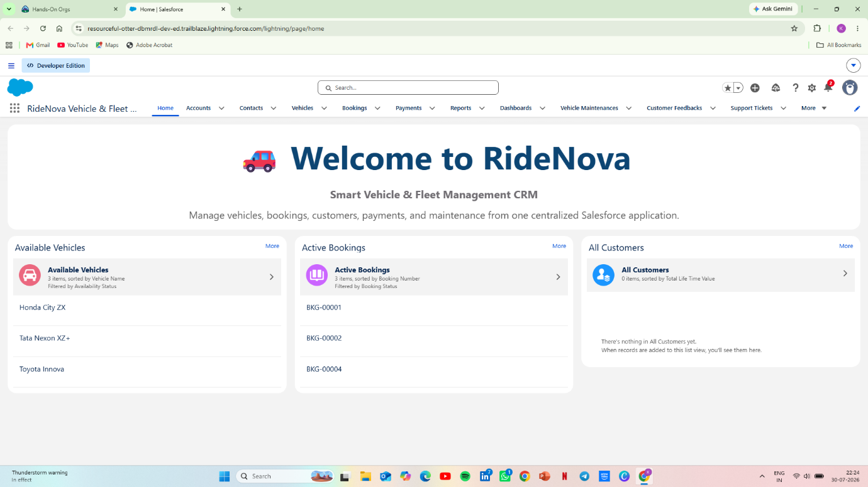

8. Challenges Faced
During the development of the RideNova project, I faced several challenges while designing the application and implementing different Salesforce features.

The major challenges were:
• Designing proper relationships between custom objects.
• Creating validation rules without affecting existing records.
• Building record-triggered flows for business automation.
• Designing reports and dashboards with meaningful data.
• Customizing Lightning Record Pages for a better user experience.
• Understanding dashboard chart configuration and report grouping.
• Organizing the application with a clean and professional user interface.

9. Learning Outcomes
This project helped me improve my Salesforce Admin skills through practical implementation.
After completing this project, I learned:
• Creating custom objects and custom fields.
• Managing lookup relationships.
• Creating validation rules.
• Building record-triggered flows.
• Designing Lightning Record Pages.
• Creating reports and dashboards.
• Managing application navigation.
• Organizing business data efficiently.
• Improving problem-solving skills while working on a real-world project.

10. Future Scope
The current version of RideNova is developed using Salesforce Admin features. In the future, this project can be enhanced by adding Salesforce Developer features.
Future improvements include:
• Lightning Web Components (LWC)
• Apex Classes
• Apex Triggers
• Email Notifications
• Approval Processes
• REST API Integration
• Mobile-friendly custom components
• Advanced analytics and dashboards

These improvements will make the application more powerful and provide a better user experience.

11. Conclusion
RideNova Vehicle & Fleet Management System is a Salesforce Admin project developed to manage vehicle rental operations efficiently.
The project includes custom objects, relationships, validation rules, record-triggered flows, reports, dashboards, and Lightning Record Pages.
This project helped me gain practical experience with Salesforce Administration and improved my understanding of business process automation.
The knowledge gained from this project will help me in future Salesforce Admin and Salesforce Developer roles.
This project strengthened my understanding of Salesforce Administration and prepared me to work on real-world Salesforce applications.

RideNova Vehicle & Fleet Management System

